Privacy Notice for Understanding and Improving the Quality of Essential Kerbside Materials
GC Insight, has invited you to take part in a research project being delivered on behalf of Zero Waste Scotland.
Before you agree to take part, we want you to know exactly how your personal data is going to be used.
This Privacy Notice should give you all the information you need to help you to decide if you want to take part in the research. If you would like to find out more, there are details at the end of this document about how to get in touch, and we would be happy to help.
What is this about?
Zero Waste Scotland (ZWS) has commissioned research to evidence the importance of quality for each core material collected at the kerbside in Scotland. The research will be used to inform future work with local authorities to improve material quality.
Through engagement with the material supply chain, the research will identify the current level of quality for each material and explore the key challenges and opportunities associated with meeting the highest quality outcomes.
What will it involve?
To achieve this research aim, we have invited representatives from organisations in the materials supply chain (such as MERFs, material reprocessors, industry bodies and manufacturers that use recycled materials) to share their thoughts and opinions with us. We will do this via a Teams call which should last approximately 45-60 minutes. The call will be recorded (both video and audio) to help our consultants to capture salient points after the interview.
You DO NOT HAVE to take part. It is completely up to you whether you do or not. And if you decide at any time to change your mind about taking part, you can do so without giving a reason.
Which organisations are involved in the research?

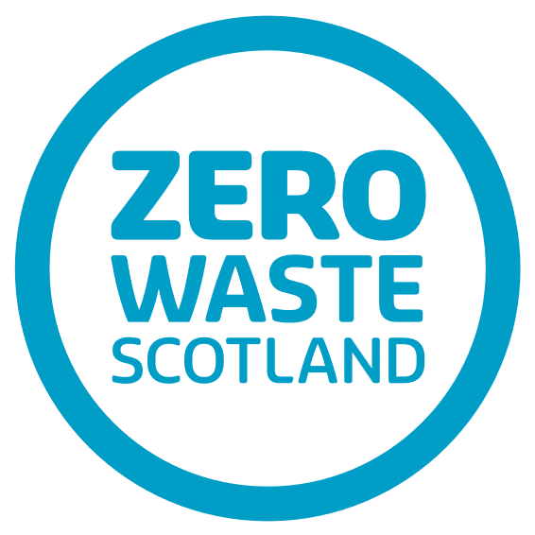 | Zero Waste Scotland is Scotland’s public body, working with government, business, and communities to rewire the economy from our current “take, make, waste” model to one where we make the most of the materials we have.
 | The independent consultancy asked by Zero Waste to conduct the research and lead the webinar in partnership with Resource Futures.
 | The independent consultancy working alongside GC Insight as part of the research team.

What information will you have about me?
Your contact data (your name, the organisation you work for and your email address and/or your telephone number) will have been obtained in one of the following three ways:
- Securely shared with us by Zero Waste Scotland as a representative stakeholder of the materials supply chain;
- Identified by one of the research team as a known contact who could support this research;
- Recommended to us by another participant of the research as someone we should invite to share their thoughts.
If you choose to take part in the research, we will additionally collect information relating to your experiences, thoughts and opinions of material quality relating to kerbside collections.
As part of the project outputs, we will:
- Provide to Zero Waste Scotland anonymised transcripts of your interview with a member of our research team.
- Share overall results grouped by themes, rather than individual responses.
Despite anonymisation and thematic grouping, it might be possible for Zero Waste Scotland to identify individuals or individual organisations as the sector we are researching is small and specific.
How will my information be stored?
All of your personal data will be securely stored on our ISO 27001 certified Microsoft Office 365 tenant (using SharePoint, Outlook and Teams platforms). We will keep your personal for no more than six months after we have finished the project (anticipated to be September 2026).
Our digital systems and internal processes comply with GDPR and other data processing regulations.
What can I do if I’m not happy with how my information is being used?

At any point, you can choose to not take part in the research, or for your information to be shown to you, changed or deleted. If you want to make a complaint about how your information is being stored or used, you can contact:

0845 644 3023 or dataprotection@gcinsight.co.uk
0303 123 1113 https://ico.org.uk

Is there any other information I might need to know?
Because we are looking after your personal data, there are certain laws that we need to obey, and certain things that we need to share with you.
Laws and codes | We follow the UK General Data Protection Regulation (GDPR) and the Data Protection Act (2018).
Data controller and data processor(s) | The data controller for your personal data for data protection purposes is Zero Waste Scotland  The data processors are GC Insight and Resource Futures.
What is ‘personal data’? | Personal data is defined under the General Data Protection Regulation (GDPR) as “any information relating to an identifiable person who can be directly or indirectly identified by reference to an identifier”.
Lawful basis for processing | Under the UK GDPR, the lawful bases we are relying on for processing your data are:  Public Task - contact details shared by ZWS, provided from our networks or shared by other respondents will be under public task. This is because Zero Waste Scotland is a public body and it is in the public interest to understand and improve the quality of materials in kerbside collections in Scotland to inform their evidence base and future decision making.  Consent – the information you share with us when you participate in the interview is done so under ‘consent’. This means that you have told us that you are happy to share this information with us.
Where your data is stored | All of the information we have about you, or we collect during the feedback group will be kept in the UK.  Your data will be stored in restricted access folders on our secure servers.
Important details about GC Insight | - Our address: Lee House, 90 Great Bridgewater Street, Manchester, M1 5JW  - Our phone number: 0845 644 3023  - Our email address: enquiries@gcinsight.co.uk  - Our company number: 3162288  - We are registered with the Information Commissioner’s Office and our number is: ZB696723
Who else might have access to your personal data | We may have to share your personal data with:  - Third party service providers that provide the necessary IT systems and software for us to be able to work.

